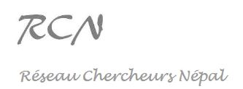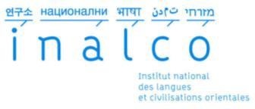

2023 Study Days
« Narratives, persuasiveness, heroes »

This document must be returned by email before the 31st of March 2023 (midnight) to: recherche.nepal@gmail.com

FULL NAME :
Statut :
Institution(S) :

Title :

Abstract (300 words max.) :

Specific needs (online/english) :

Key-words* (5 max.) [ex : Social Media / Possession / Ethnicity / Tamang / Religion] :

* the key-words will allow us to group the speakers by theme.

http://reseauchercheursnepal.fr/
Réseau Chercheur Népal – Institut national des langues et civilisations orientales (INALCO) 65 Rue des Grands Moulins, 75013 Paris

